Laud Mills

You will need three VMs in this lab, as shown in the diagram below. Use Debian for the proxy server and web server Ubuntu. The client could be Windows 10 or ubuntu or Debian. The proxy server must have two adapters. The web server impersonates the Internet. All adapters are internal.

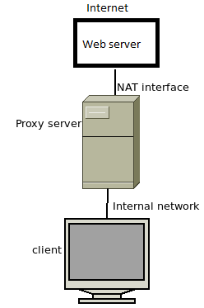

Answer the questions below, capturing a screenshot to compliment your explanations.

1. IP configuration: My Configurations

Web server: 192.168.100.39/24 Ubuntu ---192.168.1.2/24

Proxy server: 192.168.100.2/24 public adapter Debian----192.168.100.1 NAT

192.168.200.2/24 private adapter 192.168.1.1 Internal Network

Client: 192.168.200.30/24 Windows Client---192.168.1.3

These IPs are examples, you may use your own. However, you should use network ranges as indicated.

Squid tutorial: <https://linuxconfig.org/squid-proxy-configuration-tutorial-on-linux>

1. Squid’s configuration file is very extensive, so you will need to locate the exact attribute you want to configure by searching with your text editor. In particular, you will need to configure the items below.

Uncomment “http_access deny to_localhost”

Add appropriate ACL lines to allow access from clients

Locate the line “http_port” then either change the port or note the default value

Edit the line that starts with “cache_dir”\

http_pourt default value is 3128

1. When you are done configuring squid.conf, start the squid service. If it fails to start, then go back to squid.conf and review your configuration. Make any necessary adjustments and fix errors until you can start the squid service

1. Verify the items below.

The client should be able to ping the private adapter of the proxy server

The client should not be able to ping the web server

The proxy server should be able to ping the web server

If any of the above requirements are not met, then troubleshoot your IP and adapter configuration on all VMs.

1. Start the httpd service on the web server. Verify that:

From the proxy server you can open a web browser and connect to the web site. What does the web page display?

From the client you cannot connect yet to the web site.

Yes

1. Configure the client’s browser to point to the proxy (IP and port number). Verify that you can now view the web page from the client.

1. Stop the squid service on the proxy server, then try to view the web page again from the client. What message do you get in the client’s web browser?

Hint: clear the cache of the client’s browser.